**SECTION – 2**

**GIT BRANCHING**

**CSS ASSIGNEMENT**

**Objective: Commit HTML, CSS & JavaScript assignments into GIT.**

**SECTION-2- (CSS assignments) Steps to follow:**

1. Create a new branch 'css-assignments.

2. Switch to 'css-assignments branch.

3. Copy all CSS assignments inside 'Assignments' folder.

4.Commit CSS assignments into 'css-assignments' branch.

5. Make minor changes into README.txt file on line 1 belonging to 'css-assignments branch.

6. Commit those changed files.

7. Switch to master branch.

8. Make minor changes into README.txt file on line 3 & commit those changes into master.

9. Again switch to 'ess-assignments branch.

10. Make minor changes into few files belonging to 'css-assignments' branch.

11. Commit those changes.

12. Switch to master.

13. Merge css-assignments branch into master. Confirm all css assignments are shown in master.

14. Finally delete the 'css-assignments' branch.

**QUERY TILL STEPS: 1-13 (**Before Deleting css-assignments Branch)

Till Solving Conflict and Merging of css-assignments branch to master branch:

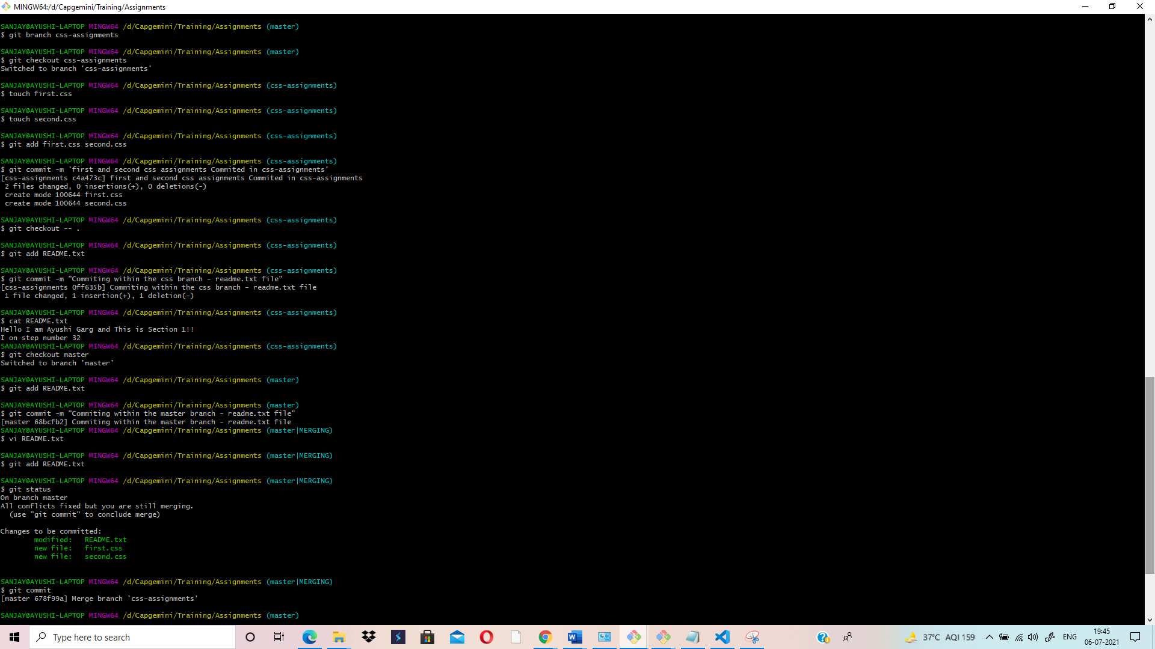

**QUERY TILL STEPS: 4-14**

After Deleting css-assignments branch-(Last Step)

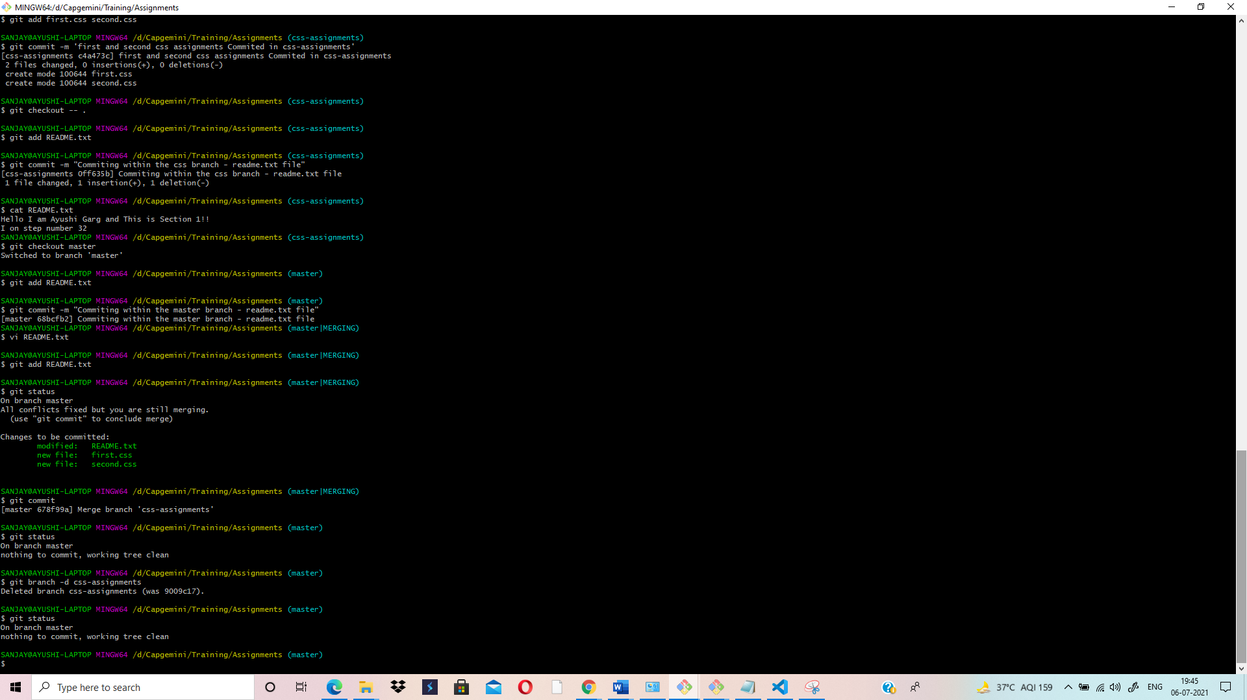

**VI EDITOR – SHOWING CONFLICT IN README.TXT FILE WHILE MERGING:**

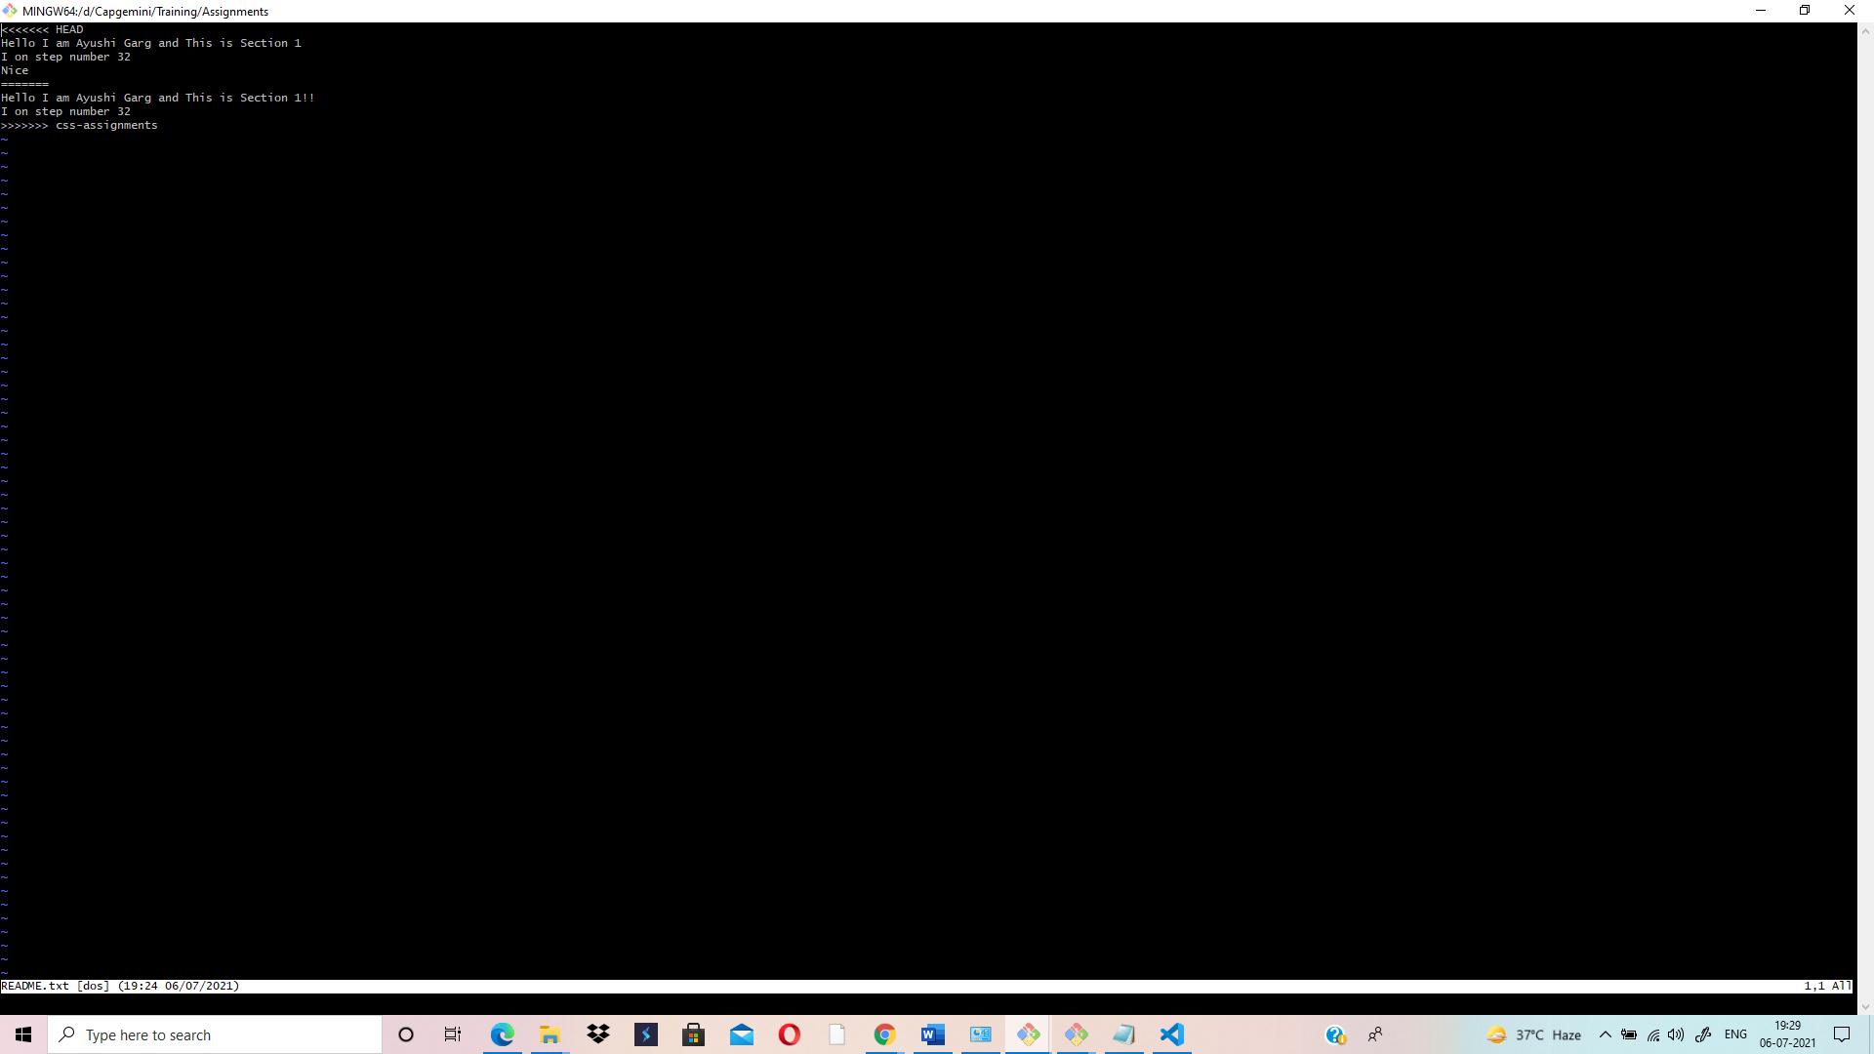

**VI EDITOR – SHOWING CONFLICT RESOLUTION IN README.TXT FILE TO COMPLETE MERGING:**



**ASSIGNMENTS FOLDER SHOWING CSS FILES ADDED– (SECTION-2):**

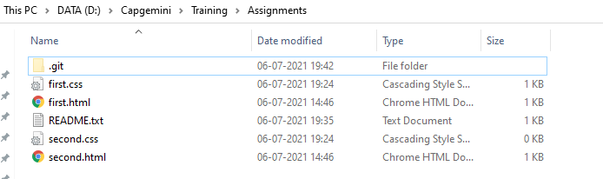

**TEXT EDITOR SCREENSHOT SHOWING CSS FILES - (SECTION-2)**

